|  | **BAHRIA UNIVERSITY, (Karachi Campus)**  *Department of Software Engineering*  **Assignment 2 - Fall 2022** |  |
| --- | --- | --- |

COURSE TITLE: **INTRODUCTION TO PSYCHOLOGY** COURSE CODE: **PSY-102**

Class: **BSE- III** Shift: **Morning**

Course Instructor: **Marvi Makhdoom** Time Allowed:  **2 Weeks**

Submission Date: 15th NOV, 2022 Max. Marks: **5 Marks**

Name: **Muhammad Shoaib Akhter Qadri**

Enrollment No: **02-131212-009**

Reg No: **79290**

**Question No. 1 [CLO3: 5 Marks]**

Choose any topic related to psychology, search 3 researches on that and report its research type, hypothesis, methodology, findings and its implications.

You can find these articles within reputable journals, such as the American Journal of Psychology, Cognitive Psychology, Emotion, Journal of Abnormal Psychology, Journal of Applied Psychology, Journal of Counseling Psychology, Journal of Educational Psychology, Journal of Personality and Social Psychology, and Memory. The study should have been performed within the past 10 years. (C2, PLO5)

**Cognitive Psychology:**

Cognitive psychology involves the study of internal mental processes—all of the things that go on inside your brain, including perception, thinking, memory, attention, language, problem-solving, and learning.1

Learning more about how people think and process information helps researchers gain a deeper understanding of how the human brain works. It also allows psychologists to develop new ways of helping people deal with psychological difficulties.

For example, by recognizing that attention is both a selective and limited resource, psychologists are able to come up with solutions that make it easier for people with attentional difficulties to improve their focus and concentration.

## Topics in Cognitive Psychology:

Cognitive psychologists explore a wide variety of topics related to thinking processes. Some of these include:

* Attention
* Choice-based behavior
* Decision-making
* Forgetting
* Information processing
* Language acquisition
* Memory
* Problem-solving
* Speech perception
* Visual perception

## History of Cognitive Psychology:

While it is a relatively young branch of psychology, it has quickly grown to become one of the most popular subfields. Cognitive psychology became more predominant during the period between the 1950s and 1970s.

Prior to this time, behaviorism was the dominant perspective in psychology. Then researchers became more interested in the internal processes that affect behavior instead of just the behavior itself.

This shift is often referred to as the cognitive revolution in psychology. During this time, a great deal of research on topics including memory, attention, and language acquisition began to emerge.

In 1967, the psychologist Ulric Neisser introduced the term cognitive psychology, which he defined as the study of the processes behind the perception, transformation, storage, and recovery of information.

## Current Research in Cognitive Psychology:

The field of cognitive psychology is both broad and diverse. It touches on many aspects of daily life. There are numerous practical applications for this research, such as providing help coping with memory disorders, making better decisions, recovering from brain injury, treating learning disorders, and structuring educational curricula to enhance learning.

Current research on cognitive psychology helps play a role in how professionals approach the treatment of mental illness, traumatic brain injury, and degenerative brain diseases.

Thanks to the work of cognitive psychologists, we can better pinpoint ways to measure human intellectual abilities, develop new strategies to combat memory problems, and decode the workings of the human brain—all of which ultimately have a powerful impact on how we treat cognitive disorders.

The field of cognitive psychology is a rapidly growing area that continues to add to our understanding of the many influences that mental processes have on our health and daily lives.

**Hypothesis of Cognitive Psychology:**

The linguistic relativity (Whorfian) hypothesis states that language influences thought. In its strongest form, the hypothesis states that language controls both thought and perception. Several experiments have shown that this is false. The weaker form of the hypothesis, which states that language influences thought, has been held to be so vague that it is unprovable. The argument presented herein is that the weaker Whorfian hypothesis can be quantified and thus evaluated. Models of cognition developed after Whorf's day indicate ways in which thought can be influenced by cultural variations in the lexical, syntactical, semantic, and pragmatic aspects of language. Although much research remains to be done, there appears to be a great deal of truth to the linguistic relativity hypothesis. In many ways the language people speak is a guide to the language in which they think. (PsycINFO Database Record (c) 2016 APA, all rights reserved)

**Methodology of Cognitive Psychology:**

Cognitive psychologists use various methods to explore how humans think. These methods include

1. laboratory or other controlled experiments,
2. psychobiological research,
3. self-reports, case studies, naturalistic observation,

(iv) computer simulations and artificial intelligence.

**Implications of Cognitive Psychology:**

Cognitive psychology plays an important role in **understanding the processes of memory, attention, and learning**. It can also provide insights into cognitive conditions that may affect how people function.

**Emotion**

According to the American Psychological Association (APA), emotion is defined as “**a complex reaction pattern, involving experiential, behavioral and physiological elements**.” Emotions are how individuals deal with matters or situations they find personally significant.

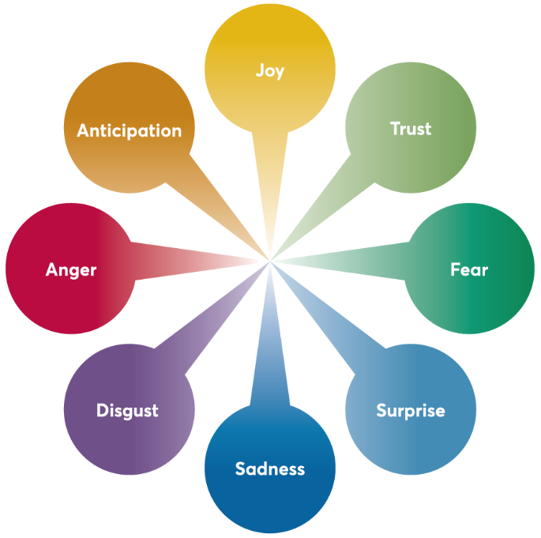

### The Process Of Emotion

While there is debate about sequence, there is general agreement that emotions, as mentioned earlier, are made up of three parts: subjective experiences, physiological responses and behavioral responses. Let’s look at each of these parts in more detail.

## Emotions And Psychology:

Theories and hypotheses about emotions date back centuries. In fact, basic or primary emotions are referenced in the Book of Rights, a first-century Chinese encyclopedia. Emotion is much harder to measure and properly define than many other human responses. Much of the study that has been done in emotional psychology is about basic emotions, our psychological and behavioral responses, and the role of emotional intelligence in our lives.

**Methodology of Emotion:**

Emotions are physical and instinctive, instantly prompting bodily reactions to threat, reward, and everything in between. The bodily reactions can be measured objectively by **pupil dilation (eye tracking), skin conductance (EDA/GSR), brain activity (EEG, fMRI), heart rate (ECG), and facial expressions**.

**Hypothesis of Emotion:**

**The one-network hypothesis** comes from the social constructivist perspective. This hypothesis points out that an emotional experience is comprised of behavior, thoughts, feelings, and physiology, all which activate different parts and structures of the brain.

Summary Theories of Emotion. Emotion is **a complex, subjective experience accompanied by biological and behavioral changes**. Emotion involves feeling, thinking, activation of the nervous system, physiological changes, and behavioral changes such as facial expressions

**Findings and Implication of Emotion:**

Emotional implication occurs when the author implies without specifically delineating the emotional tonality (such as the intentions, motives, attitudes, and/or feelings) that gives rise to an experience or is engendered by one.

Emotion has a substantial influence on the cognitive processes in humans, including perception, attention, learning, memory, reasoning, and problem solving. Emotion has a particularly strong influence on attention, especially modulating the selectivity of attention as well as motivating action and behavior. This attentional and executive control is intimately linked to learning processes, as intrinsically limited attentional capacities are better focused on relevant information. Emotion also facilitates encoding and helps retrieval of information efficiently. However, the effects of emotion on learning and memory are not always univalent, as studies have reported that emotion either enhances or impairs learning and long-term memory (LTM) retention, depending on a range of factors. Recent neuroimaging findings have indicated that the amygdala and prefrontal cortex cooperate with the medial temporal lobe in an integrated manner that affords (i) the amygdala modulating memory consolidation; (ii) the prefrontal cortex mediating memory encoding and formation; and (iii) the hippocampus for successful learning and LTM retention. We also review the nested hierarchies of circular emotional control and cognitive regulation (bottom-up and top-down influences) within the brain to achieve optimal integration of emotional and cognitive processing. This review highlights a basic evolutionary approach to emotion to understand the effects of emotion on learning and memory and the functional roles played by various brain regions and their mutual interactions in relation to emotional processing. We also summarize the current state of knowledge on the impact of emotion on memory and map implications for educational settings. In addition to elucidating the memory-enhancing effects of emotion, neuroimaging findings extend our understanding of emotional influences on learning and memory processes; this knowledge may be useful for the design of effective educational curricula to provide a conducive learning environment for both traditional “live” learning in classrooms and “virtual” learning through online-based educational technologies.

**Journal of Educational Psychology:**

The main purpose of the Journal of Educational Psychology® is **to publish original, primary psychological research pertaining to education across all ages and educational levels**.

Although the discipline of educational psychology includes numerous theories, many experts identify five main schools of thought: **behaviorism, cognitivism, constructivism, experientialism, and social contextual learning theories**.

**Hypothesis of Educational Psychology:**

Hypothesis is **one of the most essential elements in educational research in which variable based numeric data are collected and analysed**. So, meaning, type, importance and characteristics of a good hypothesis are discussed here.

Although the discipline of educational psychology includes numerous theories, many experts identify five main schools of thought: **behaviorism, cognitivism, constructivism, experientialism, and social contextual learning theories**.

Concept of educational psychology?

Educational psychology is the study of how people learn, including teaching methods, instructional processes, and individual differences in learning. It explores the cognitive, behavioral, emotional, and social influences on the learning process.

Methods of Educational Psychology -

* Introspection.
* The Observational Method.
* Experimental Method.
* Clinical Method.
* The Developmental or Genetic Method.
* Testing Method.

Methodology in psychology refers to **procedures researchers use to answer specific questions**. There is no single methodology that all psychologists use.

**Implication of Education Psychology:**

Educational psychology is important because it has the potential to help both students and teachers. It **provides important information for educators to help them create educational experiences, measure learning, and improve student motivation**.



The educational implication of Piaget's theory is **the adaptation of instruction to the learner's development level**. It is important that the content of instruction needs to be consistent with the developmental level of the learner.

Developmental psychology can **help you identify the many forces that affect growth, maturation, learning, and development and that affect your learners' behavior**. It can also make you more understanding of the varieties of behavior you will find among learners.